6/16/2023

AYSO Region 1174 and AYSO Alliance’s North Alabama Alliance Football Club is committed to enriching the lives of children through the beautiful game of soccer and we are hosting our 2023-2024 season fundraiser to raise funds for our programs.
With your help, we hope to help even more players get out on the field and experience all the joys and benefits that come with youth soccer: promoting healthy habits, boosting confidence, building friendships and creating lasting memories.
AYSO is a 501c 3 with the mission to develop and deliver quality youth soccer programs throughout the country which promote a fun, family environment built on the foundation of our six Philosophies of Everyone Plays, Balanced Teams, Open Registration, Positive Coaching, Good Sportsmanship, and Player development. As part of open registration, we want to be able to accept all players in all our program levels that wish to play. This is accomplished through the generosity of donors that can sponsor those that are less fortunate.
- A player level donation helps sponsor a single player to one of our Core programs or partial fees for one of our competitive Alliance players. We have many players each year who need access to our programs but cannot afford it. Your donations give these players opportunities they might not otherwise have.
- Team level sponsorships help sponsor team expenses such as equipment and travel expenses for competitive teams or regional tournament entry for our core program teams.
- Club level sponsorships help cover organizational expenses for larger equipment purchase and field fees. These also help with other regional operating expenses to help keep the costs as low as possible for all players. These could be directed sponsorships for practice jerseys that would reflect sponsor logo. Etc.
- Area level sponsorships benefit players from across our entire North Alabama area. AYSO is divided into local regions, geographic areas, and then geographic sections. Our Area encompasses all Northern and Central Alabama and into portions of Tennessee. These Area sponsorships cover expenses like local tournaments and starting new regions in different locations around our Area as we attempt to grow opportunities for players in our area. Limited sponsorship opportunities available include the North Alabama Area Tournament Presenting sponsorship and the AYSO Alliance Jersey sponsorship. Each area level sponsorship will be worked with the donor to match them to the best possible choice to maximize their exposure from the sponsorship.

As a sponsor, we are pleased to offer sponsor benefits that include website and social media recognition based on donation level, banner and signage recognition at home field locations, email recognition in our email communications to all of our patrons, ability to set up vendor booths at large events hosted by AYSO Area 5C, AYSO 1174, or AYSO Alliance. Attached is a list of the benefits for the sponsorship levels.
Benefit | Player | Team | Club | Area
Website recognition | Region | Region | Region | Region, Area
Social Media | Region | Region | Region and Club | Region, Club, Area
Home Field Banner | Shared Banner | Shared Banner | Shared banner and individual banner; travel banners for the club | Banner at area tournaments and event +club benefits
Email Recognition | Sponsor recognition emails | Sponsor recognition emails | Featured in all club email communications for sponsor thanks | Club benefits + thanks in all tournament and other area events
Booth setup |  |  | Home Games/Events | Area Tournaments/Events
Tax Donation Letter | Yes | Yes | Yes | Yes

Thank you for your consideration and we look forward to discussing how your organization and AYSO 1174/AYSO Alliance can partner together to make an impact in our community.

Best regards,
David Kelley Jason Lanier
AYSO 1174 Regional Commissioner and AYSO Area 5C Area Director

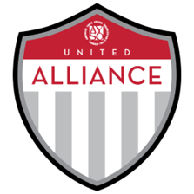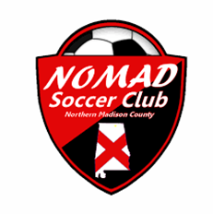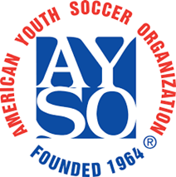

AYSO Region 1174: Nomad Soccer Club
AYSO Alliance: North Alabama Alliance FC
Sponsorship Opportunities

Sponsorship Level | Sponsorship Amount
Player Level | $100-$400
Team Level | $401-$1000
Club Level | $1001-$5000
Area Level | $5001 and up
Sponsorship Benefits
Recognition on AYSO regional and area websites (based on sponsorship level), Recognition on all applicable social media pages as a program sponsor, Recognition on field banners and signage at applicable field locations, Recognition on banners and signage for tournaments at Area events for Area level sponsorship, Recognition on travel banners for club level sponsors, Recognition in email communication to parents, Opportunities to set-up booths during home game weekends or club events
****Tax donation letters for all donations*****

